Project Title:
AI System to Automatically Review and Summarize Research Papers

Internship Program: Infosys Internship
Intern Name: Pari Purswani
Mentor: Ms. M.Likhita

Project Overview

Objective
This system automates the process of creating systematic reviews of academic papers
through a structured workflow. It handles everything from initial paper search to final draft
generation using a directed graph architecture.
The current phase focuses on automated paper retrieval and dataset preparation, which forms the foundation for AI-driven summarization.

Task Breakdown (As Assigned by Mentor)

The following tasks were defined for the initial phase of the project:
- Environment Setup
- Automated Research Paper Search
- Paper Selection and PDF Download
- Dataset Preparation
The implementation details for each task are explained below

Environment Setup

The project environment was set up using Python, and development was carried out using Visual Studio Code (VS Code). All required libraries and dependencies needed for API access, file handling, PDF processing, and dataset preparation were installed and configured successfully.
Libraries Used
- requests – for accessing the Semantic Scholar API
- os – for directory and file management
- datetime – for timestamp-based folder organization
- csv – for creating and maintaining the dataset
- pandas – for handling structured dataset information
- PyPDF – for future PDF text extraction and processing
The environment setup ensured smooth execution of the automated paper retrieval and dataset preparation tasks.

Automated Paper Search
The system uses the Semantic Scholar Graph API to automatically retrieve research papers based on a user-provided topic. Once the topic is entered, an API request is sent to Semantic Scholar, and relevant paper metadata is fetched programmatically.
The retrieved metadata includes:
- Paper title
- Authors
- Year of publication
- Open-access PDF availability
The system processes all retrieved papers and clearly distinguishes between papers with and without open-access PDFs. Titles of papers without PDFs are displayed with a “No PDF” indication, while papers with available PDFs are numbered and marked accordingly.
Only papers with open-access PDFs are selected for further processing and download. Basic error handling is implemented to detect API-related issues (such as server errors) and notify the user when a request fails or needs to be retried.
This approach ensures transparency in paper selection and allows only accessible research papers to move forward in the pipeline.

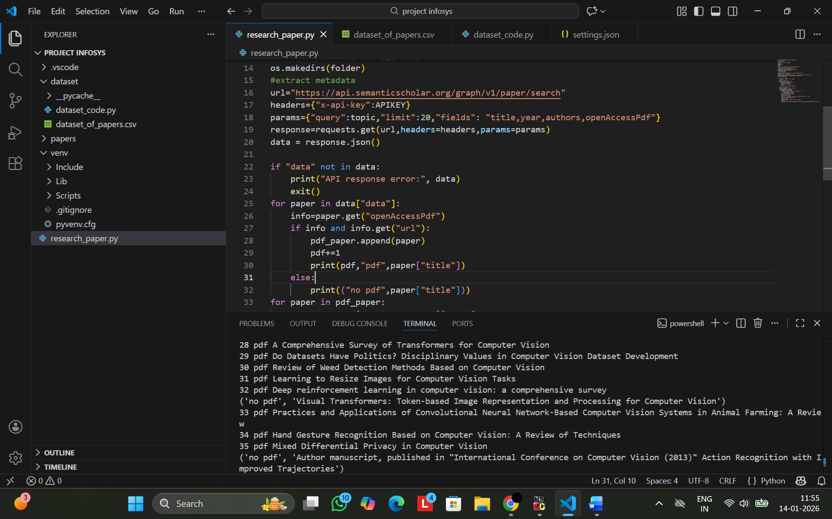

Code Snippet: Automated Research Paper Retrieval and PDF Availability Filtering
This code demonstrates how the system retrieves research papers using the Semantic Scholar API and filters them based on open-access PDF availability.

Paper Selection and PDF Download
From the retrieved search results, the system selects only papers with open-access PDFs and downloads them automatically. Each PDF is saved in a topic-specific folder named with the research topic and a timestamp, ensuring that previously downloaded files are not overwritten.
Papers are numbered sequentially within each topic. For example, papers on Computer Vision are saved as Computer Vision Paper 1, Computer Vision Paper 2, and so on, while papers on other topics like Artificial Intelligence or Natural Language Processing start a new sequence for that topic.
During the download process, the system prints progress messages to the console, indicating which papers are being downloaded and confirming successful storage.
This approach ensures a systematic, reproducible, and organized collection of research papers, forming a reliable dataset for subsequent analysis and summarization.
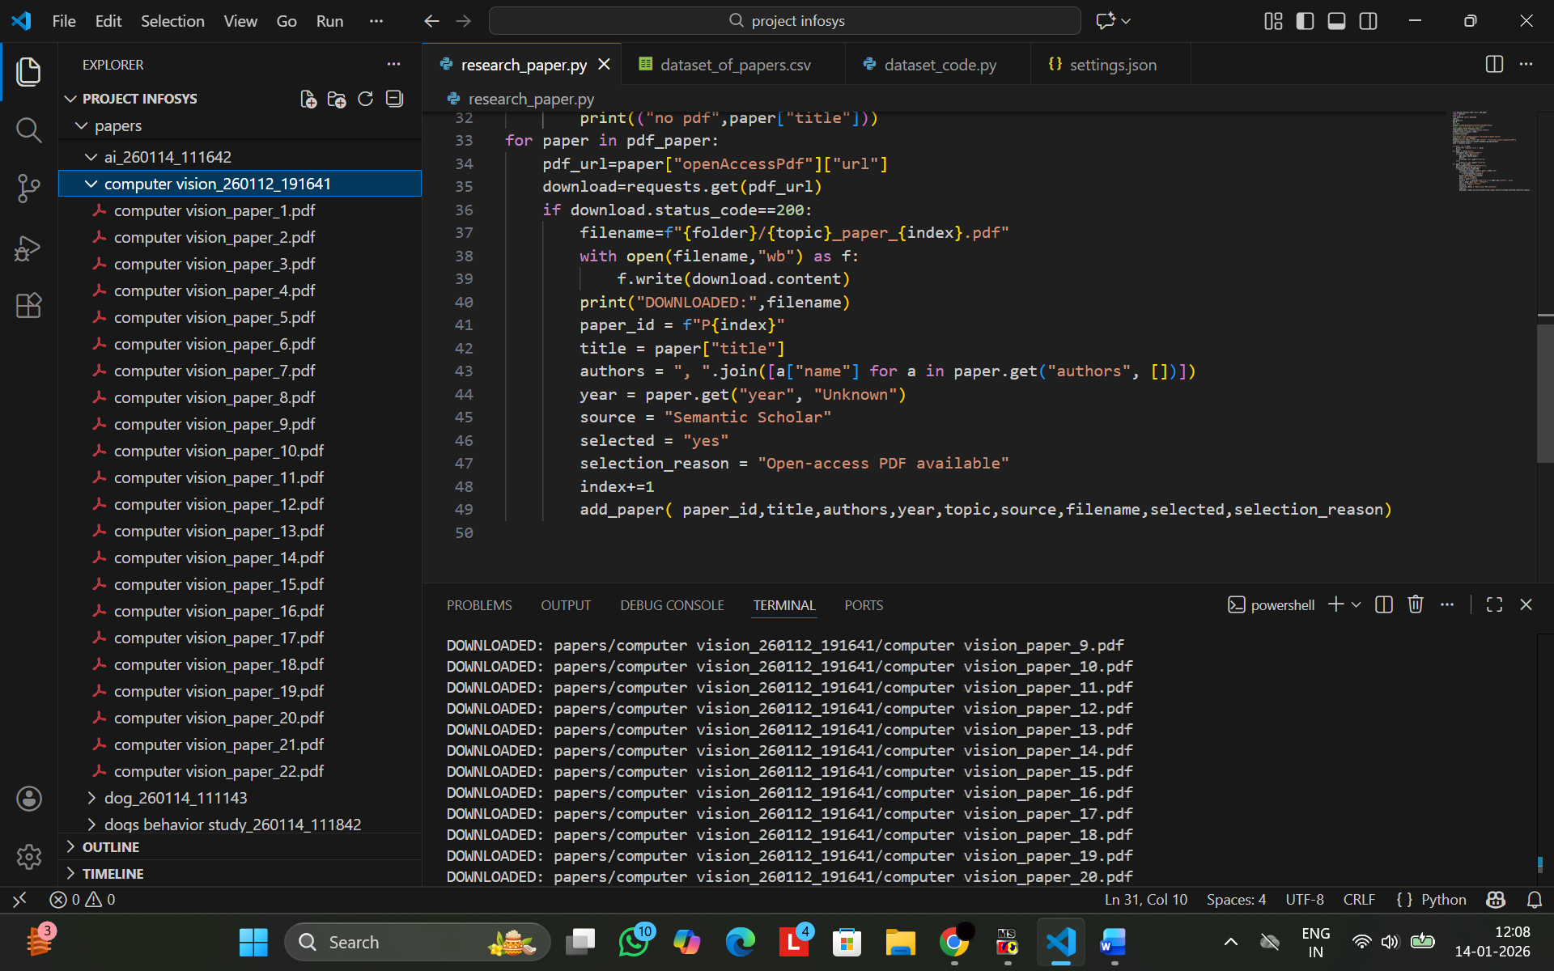
Code Snippet: PDF Download and Organized Storage
This code demonstrates how the system downloads research papers with open-access PDFs and stores them in topic-specific, timestamped folders, numbering papers sequentially within each topic.

Dataset Preparation

After downloading the research papers, the system creates a structured dataset to record key information for each paper. The dataset includes:

Paper ID

Title

Authors

Year of publication

Topic

Source

File path of the downloaded PDF

Selection status

Reason for selection

The dataset is stored in a CSV file (dataset_of_papers.csv) within a dedicated dataset folder. If the folder or file does not exist, the system creates them automatically. Each new entry is appended to the CSV, ensuring that previously recorded data is preserved.

This approach ensures a reproducible, organized, and traceable record of all research papers, forming a reliable input for subsequent analysis and AI-based summarization.

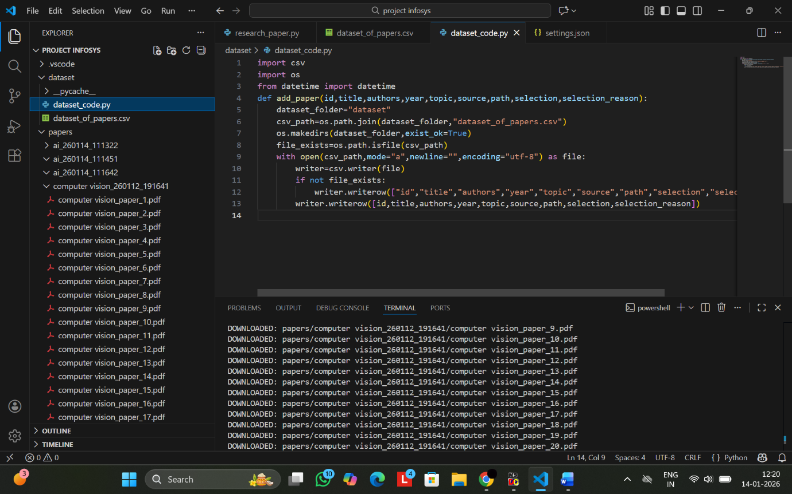
Code Snippet: Dataset Creation
This code demonstrates how the system creates and maintains the structured dataset, appending new entries to the CSV file while preserving existing records.
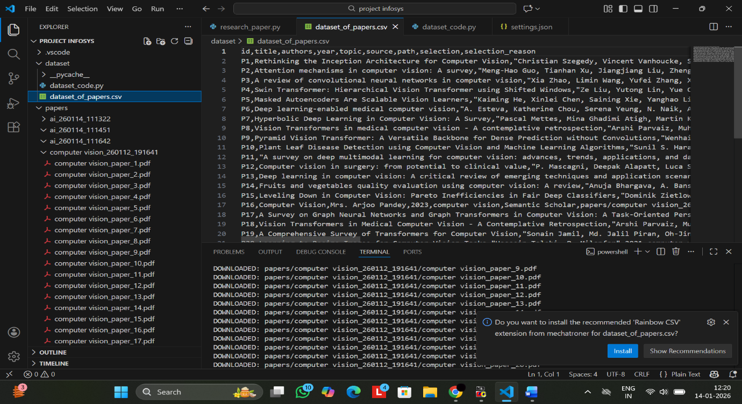

Dataset Snapshot: CSV File
This snapshot shows the structured CSV file (dataset_of_papers.csv) containing all selected research papers with key metadata, including Paper ID, Title, Authors, Year, Topic, Source, File Path, Selection Status, and Selection Reason.

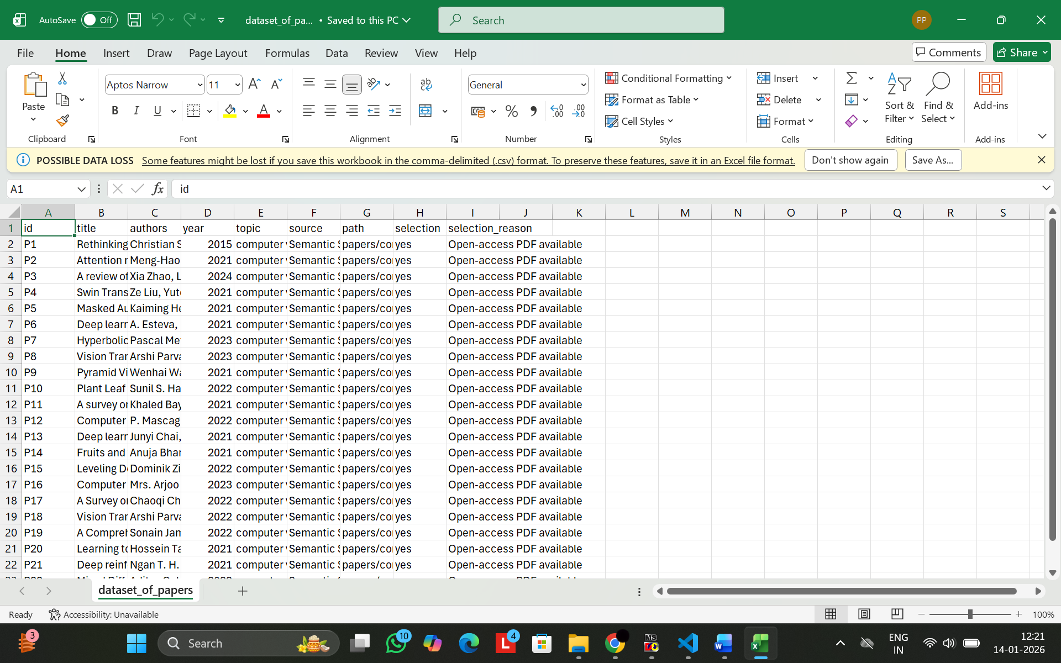

Dataset Snapshot: Excel File
This snapshot shows the same dataset opened in Excel, demonstrating clear tabular organization, sequential numbering per topic, and easy readability for review or further analysis.

